

REG NO : 22BCE9454 , LAB SLOT : L9+L10 , CSE2005

LAB EX01

NAME : MANDA BHARATH KRISHNA SIVA SRI SAI KUMAR

Table of contents :

1. Write a Java Program to print Fibonacci series
2. Write a Java Program to check whether the number is an amstrong number or not
3. Write a Java Program to print the prime numbers between 1 to 50
4. Write a Java Program to print area of circle and area of triangle
5. Write a Java Program to perform arithmetic operations.

FIBONACCI SERIES

Write a Java Program to print Fibonacci series

ALGORITHM :

STEP 1 : Initialize two variables to 0 and 1 respectively.

STEP 2: Print the value of the first variable (0).

STEP 3: Print the value of the second variable (1).

STEP 4: For each subsequent number in the series, add the previous two numbers together and print the result

STEP 5 : Repeat step 4 until the desired number of terms have been printed

import java.util.Scanner;

public class FibonacciSeries {

public static void main(String[] args) {

Scanner scanner = new Scanner(System.in);

System.out.print("Enter the number of terms you want to print: ");

int numberofTerms = scanner.nextInt();

int firstTerm = 0, secondTerm = 1;

System.out.print(firstTerm + " " + secondTerm + " ");

for (int i = 3; i <= numberofTerms; i++) {

int nextTerm = firstTerm + secondTerm;

System.out.print(nextTerm + " ");

firstTerm = secondTerm;

secondTerm = nextTerm;

}

scanner.close();

}

}

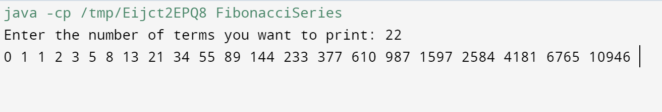OUTPUT :

AMSTRONG NUMBER

Write a Java Program to check whether the number is an amstrong number or not

ALGORITHM :

STEP 1. Read the input number.

STEP 2. Initialize a variable to 0.

STEP 3. Calculate the number of digits in the input number.

STEP 4. For each digit in the input number, compute its cube and add it to the variable.

STEP 5. If the computed sum is equal to the input number, it is an Armstrong number. Otherwise, it is not.

import java.util.Scanner;

public class ArmstrongNumber {

public static void main(String[] args) {

Scanner scanner = new Scanner(System.in);

System.out.print("Enter a number: ");

int number = scanner.nextInt();

int originalNumber = number;

int numberOfDigits = 0;

while (originalNumber != 0) {

originalNumber /= 10;

numberOfDigits++;

}

int sum = 0;

originalNumber = number;

while (originalNumber != 0) {

int digit = originalNumber % 10;

int power = 1;

for (int i = 0; i < numberOfDigits; i++) {

power \*= digit;

}

sum += power;

originalNumber /= 10;

}

if (sum == number) {

System.out.println(number + " is an Armstrong number.");

} else {

System.out.println(number + " is not an Armstrong number.");

}

scanner.close();

}

}

OUTPUT :

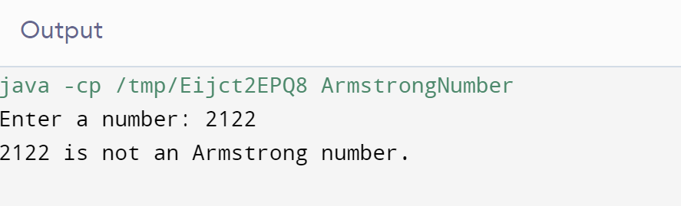

PRIME NUMBERS

Write a Java Program to print the prime numbers between 1 to 50

ALGORITHM :

STEP 1. Loop through all numbers from 2 to 50.

STEP 2. For each number, loop through all numbers from 2 to the number itself.

STEP 3. If the number is divisible by any number other than 1 and itself, it is not a prime number, so move on to the next number.

STEP 4. If the loop completes without finding any divisors other than 1 and itself, the number is a prime number, so print it.

public class PrimeNumbers {

public static void main(String[] args) {

System.out.println("Prime numbers between 1 and 50:");

for (int i = 2; i <= 50; i++) {

boolean isPrime = true;

for (int j = 2; j < i; j++) {

if (i % j == 0) {

isPrime = false;

break;

}

}

if (isPrime) {

System.out.print(i + " ");

}

}

}

}

OUTPUT :

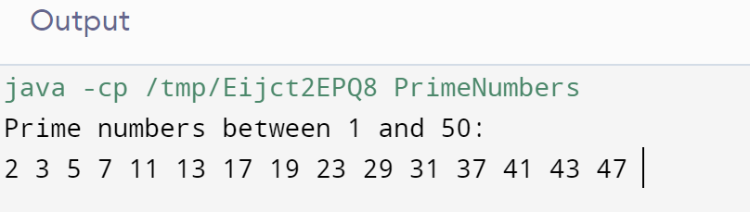

AREA OF CIRCLE AND TRIANGLE

Write a Java Program to print area of circle and area of triangle

ALGORITHM:

For calculating the area of a circle:

STEP 1. Read the radius of the circle.

STEP 2. Calculate the area of the circle using the formula: area = pi\* radius" radius.

STEP 3. Print the area of the circle.

For calculating the area of a triangle:

STEP 1. Read the base and height of the triangle.

STEP 2. Calculate the area of the triangle using the formula: area = (base height)/2.

STEP 3. Print the area of the triangle

import java.util.Scanner;

public class Area {

public static void main(String[] args) {

Scanner scanner = new Scanner(System.in);

// Calculate area of a circle

System.out.print("Enter the radius of the circle: ");

double radius = scanner.nextDouble();

double circleArea = Math.PI \* radius \* radius;

System.out.println("Area of the circle = " + circleArea);

// Calculate area of a triangle

System.out.print("Enter the base of the triangle: ");

double base = scanner.nextDouble();

System.out.print("Enter the height of the triangle: ");

double height = scanner.nextDouble();

double triangleArea = (base \* height) / 2;

System.out.println("Area of the triangle = " + triangleArea);

scanner.close();

}

}

OUTPUT :

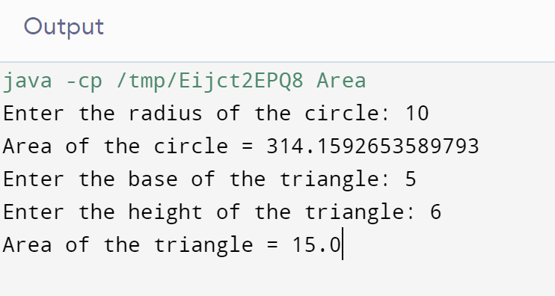

ARITHMETIC OPERATIONS

Write a Java Program to perform arithmetic operations.

ALGORITHM:

STEP 1. Read two operands and the operator from the user.

STEP 2. Use a switch statement to perform the operation based on the operator.

a. If the operator is '+', add the two operands.

b. If the operator is -, subtract the second operand from the first.

c. If the operator is "\*, multiply the two operands.

d. If the operator is '/, divide the first operand by the second.

e. If the operator is '%', calculate the remainder when the first operand is divided by the second.

STEP 3. Print the result of the operation.

import java.util.Scanner;

public class ArithmeticOperations {

public static void main(String[] args) {

Scanner scanner = new Scanner(System.in);

// Read two operands and the operator

System.out.print("Enter first operand: ");

double operand1 = scanner.nextDouble();

System.out.print("Enter second operand: ");

double operand2 = scanner.nextDouble();

System.out.print("Enter operator (+, -, \*, /, %): ");

char operator = scanner.next().charAt(0);

// Perform the operation based on the operator

double result = 0;

switch (operator) {

case '+':

result = operand1 + operand2;

break;

case '-':

result = operand1 - operand2;

break;

case '\*':

result = operand1 \* operand2;

break;

case '/':

result = operand1 / operand2;

break;

case '%':

result = operand1 % operand2;

break;

default:

System.out.println("Invalid operator!");

break;

}

// Print the result of the operation

System.out.println("Result: " + result);

scanner.close();

}

}

OUTPUT:

